**Lab # 12 Structures in C**

**Reading Task 1:**

**Working with Structures**

Chapter 10 Structures (pages 363 to 378) from the book: “Let us C” by Yashavant Kanetkar.

**In-Lab Task 1:**

Write a C Program that does the following:

1. Declares a C-Structure called ‘**car**’.

2. It should contain the following elements a) A char array of size 20 to hold the **make** of the car e.g. Suzuki.

b) A char array of size 20 to hold the **model** of the car e.g. Alto

c) An integer **capacity** to store the seating capacity.

d) A floating point number to hold the **weight** of the empty vehicle.

3. Then declare 3 variables of this type of structure.

4. Let the user populate the elements of these variables.

5. Print these structures

**Program:**

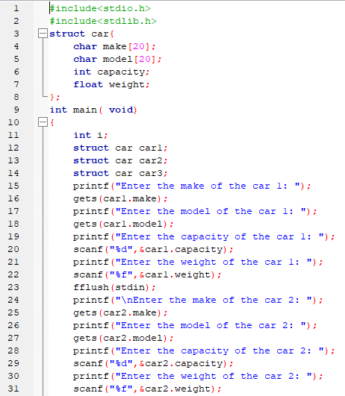

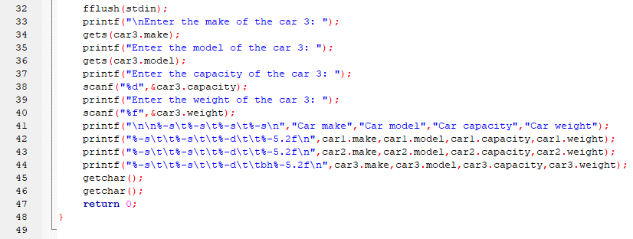

**Output:**

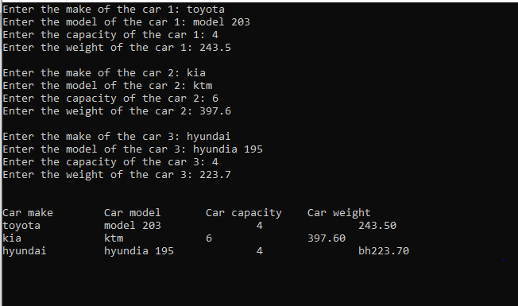

**In-Lab Task 2 a:**

Write a C program that declares an array of structures of type ‘**car**’ from previous example, and asks the user to fill in the elements. Once all the structures have been initialized, the program should present a menu to the user so that he can print a certain structure, or modify its elements.

**Program:**

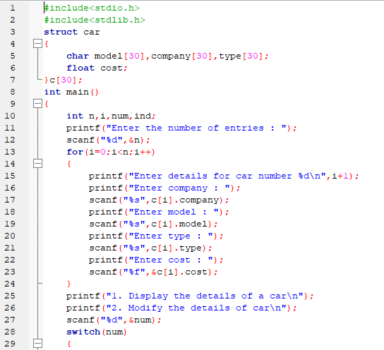

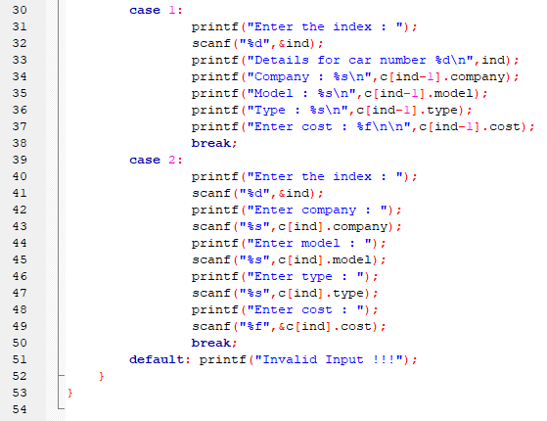

**Output:**

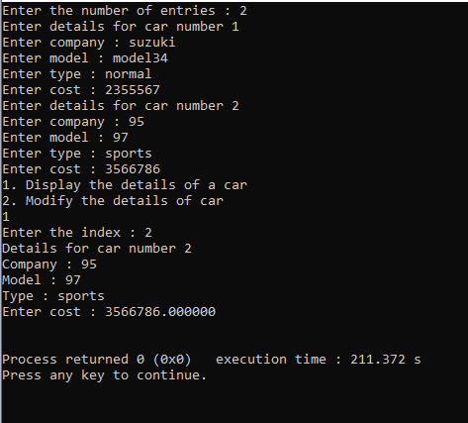

**In-Lab Task 2 b:**

There is a structure called employee that holds information like employee code, name, date of joining. Write a program to create an array of the structure and enter some data into it. Then ask the user to enter current date. Display the names of those employees whose tenure is 3 or more than 3 years according to the given current date.

**Program:**

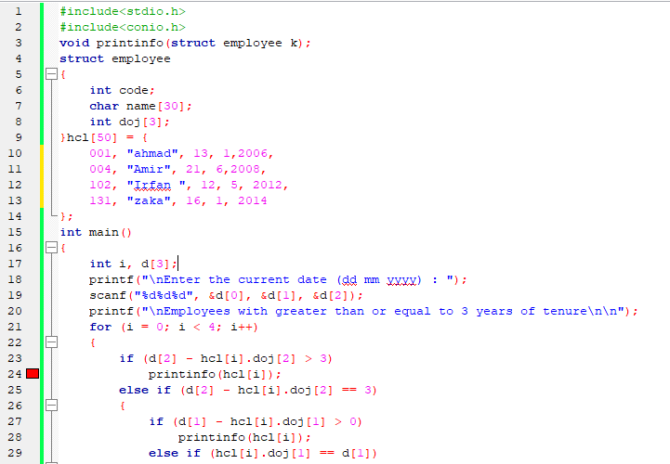

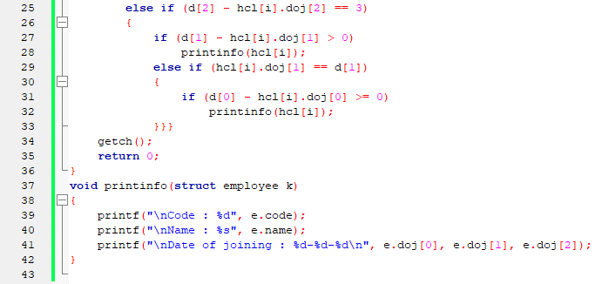

**Output:**

**Critical analysis:**